Reading 6  
Lonneke Lammers  
10371672

Question

1. Pick three concepts covered in Lecture 9 - Interaction (e.g., Brushing & Linking) and relate them to the taxonomy presented in Heer & Shneiderman Table
   1. How do the interaction concepts fit to their taxonomy?

Answer

J. Heer and B. Shneiderman describe 12 task types grouped into three high-level categories, which incorporate the critical tasks that enable iterative visual analysis, including visualization creation, interactive querying, multiview coordination, history and collaboration.

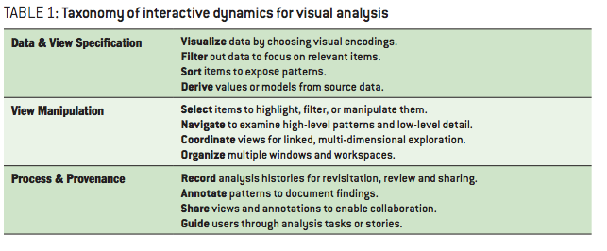In Lecture 9 – Interaction, they talk about interaction concepts. If you want to let people focus on a part, you can make use of a focusing context tool like fish-eye view or a hyoerbolic tree. Also with brushing and linking you make make data more clear to a viewer/user of that particular data. A visualisator can make use of links which the user can use to see relations between or of particular things in for example a timeslot. The change in a representation in one view affects the representation in another view. Linking is a change of parameters in a data representation which is reflected in another connected data representation. Brushing means highlighting data that you selected in a view in other connected data representations.

Fishing eye is a focusing concept which could play an important role when a dat analyst want to zoom in on particular data and see exactly what is happening right there. You can ‘filter’ your own data, and make bigger what is more important for example, or what contains the biggest quantity. This makes is more clear for a user, especially for the first impression.

Linking and brushing can be important when you have to deal with a lot of data in a data visualisation. It of course depends on what kind of data you’ll visualize, but shapes, proximinity and containment (like drawing a box around something) play a big role in this concept. The viewer must be able to ‘play’ with the data, in a way that it is clear what you see and what it means.

Also filtering of data is an important thing. Is something an outlier of is it a discovery? What do you have to filter out of the visualization and what not? By excluding not important data you can make a visualisation stand or fal.